**9. ReactJS-HOL**

**Create a React Application named “cricketapp” with the following components:**

**ListofPlayers.js**

// src/components/ListofPlayers.js

import React from "react";

const players = [

{ name: "Virat Kohli", score: 95 },

{ name: "Rohit Sharma", score: 85 },

{ name: "KL Rahul", score: 40 },

{ name: "Hardik Pandya", score: 65 },

{ name: "Jasprit Bumrah", score: 75 },

{ name: "Ravindra Jadeja", score: 90 },

{ name: "Shikhar Dhawan", score: 55 },

{ name: "Rishabh Pant", score: 80 },

{ name: "Suryakumar Yadav", score: 92 },

{ name: "Mohammed Shami", score: 35 },

{ name: "Shubman Gill", score: 60 },

];

const ListofPlayers = () => {

const allPlayers = players.map((player, index) => (

<li key={index}>

{player.name} - {player.score}

</li>

));

const below70 = players

.filter((player) => player.score < 70)

.map((player, index) => (

<li key={index}>

{player.name} - {player.score}

</li>

));

return (

<div>

<h2>All Players</h2>

<ul>{allPlayers}</ul>

<h2>Players with Score &lt; 70</h2>

<ul>{below70}</ul>

</div>

);

};

export default ListofPlayers;

**IndianPlayers.js**

// src/components/IndianPlayers.js

import React from "react";

const T20players = ["Virat", "Rohit", "KL", "Hardik", "Bumrah"];

const RanjiTrophy = ["Sarfaraz", "Jurel", "Abhimanyu", "Saurabh"];

const IndianPlayers = () => {

const allPlayers = [...T20players, ...RanjiTrophy];

const evenPlayers = allPlayers.filter((_, i) => i % 2 === 0);

const oddPlayers = allPlayers.filter((_, i) => i % 2 !== 0);

return (

<div>

<h2>All Players (Merged)</h2>

<ul>

{allPlayers.map((player, index) => (

<li key={index}>{player}</li>

))}

</ul>

<h3>Even Team Players</h3>

<ul>

{evenPlayers.map((player, index) => (

<li key={index}>{player}</li>

))}

</ul>

<h3>Odd Team Players</h3>

<ul>

{oddPlayers.map((player, index) => (

<li key={index}>{player}</li>

))}

</ul>

</div>

);

};

export default IndianPlayers;

**App.js**

// src/App.js

import React from "react";

import ListofPlayers from "./components/ListofPlayers";

import IndianPlayers from "./components/IndianPlayers";

function App() {

const flag = true; // change to false to show IndianPlayers

return (

<div className="App">

<h1>Cricket App</h1>

{flag ? <ListofPlayers /> : <IndianPlayers />}

</div>

);

}

export default App;

**Output**

**flag = true**

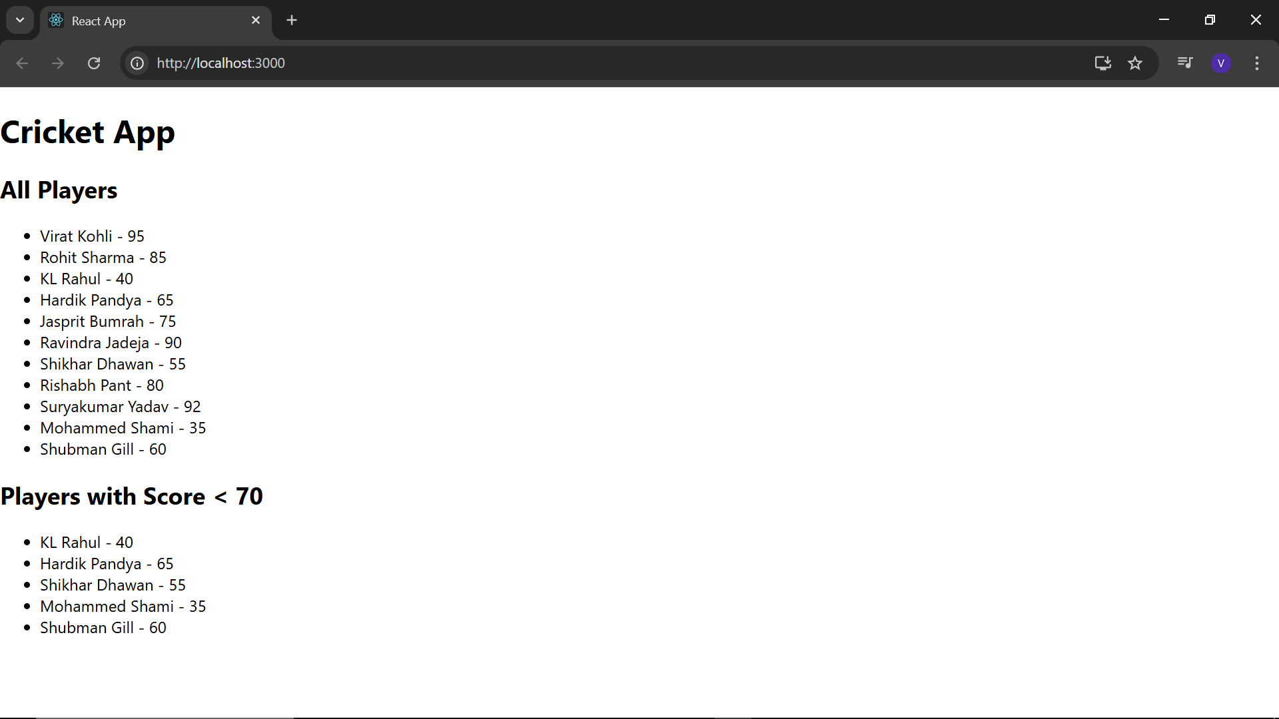**flag = false**

